Please attach photo
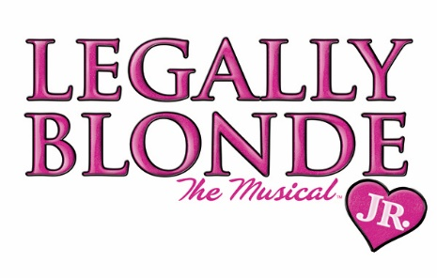

AUDITION SHEET
Name: ____________________________________________________________________________________
Current Grade in School (2022-2023) _________________
Parents’ Name(s): _________________________________________________________________________
Address: __________________________________________________________________________________
Phone: Home_______________________ Work ________________________ Cell _____________________

Parent’s Email Address: ______________________________________________ PRINT CLEARLY!
Past performance experience: Include plays, musicals, choir, dance, etc. USE BACK IF MORE SPACE NEEDED
Show | Role | Year | Sponsoring Organization

IMPORTANT: Rehearsals for Legally Blonde Jr. will take place from noon-4 p.m. on weekdays starting July 6-July 25. Performances are scheduled for July 25-27 at 7 p.m.
I understand I MUST BE AT ALL REHEARSALS AND PERFORMANCES. Absolutely No Exceptions. Please sign below if you agree to this. *Because of our short rehearsal schedule, no absences for other activities allowed.
Yes, I understand and agree: _____________________________________________, Student
Yes, I understand and agree: _____________________________________________, parent/guardian
*The fee for this program is $125 per student, which includes large and small group voice, dance and acting coaching. There are a limited number of partial scholarships available. For more information, go to www.trfact.org

